* Create a simple project with name ‘central-config-repository’.
  + Create a folder with name ‘microservice1’
  + Create a file - microservice1-mysql-dev.yml
  + Create a file - microservice1-mysql.yml
  + Create a file - microservice1-mysql-prod.yml

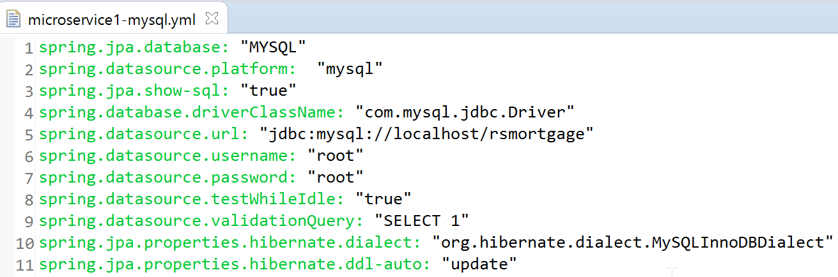

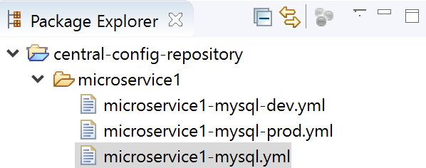

* Create and upload the project into Github.com

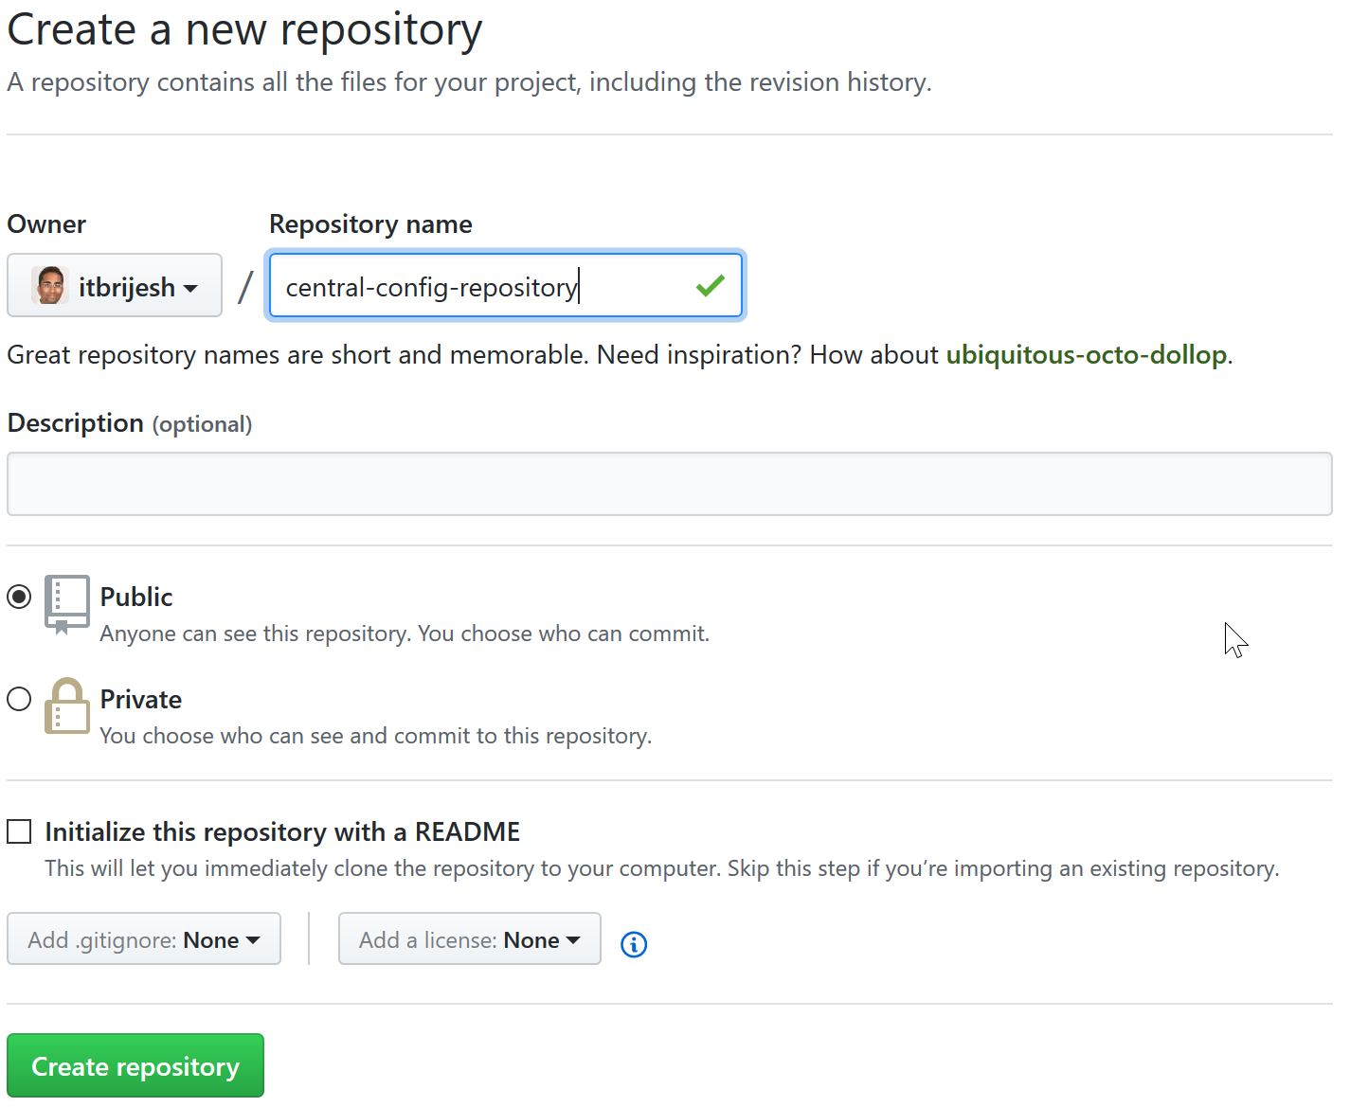

**Run below commands to upload your local files to above github repository:**

> git init

> git remote add origin <https://github.com/itbrijesh/central-config-repository.git>

> git add –A

> git status

> git commit -m "Added database properties files for microservice1"

> git push origin master

* Create a Spring starter project with Spring Cloud Config & Actuator.

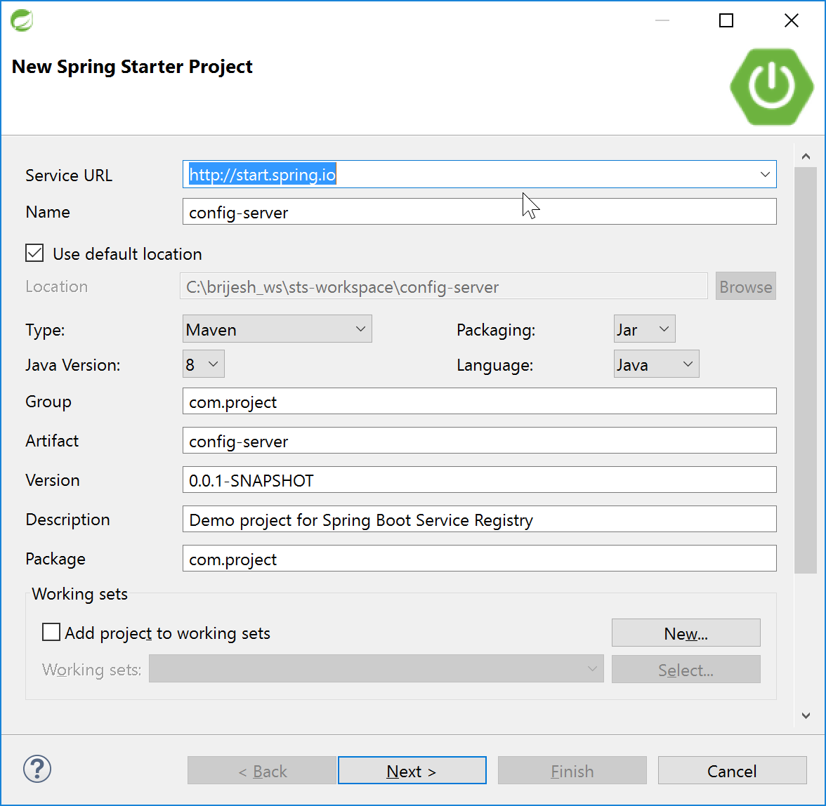

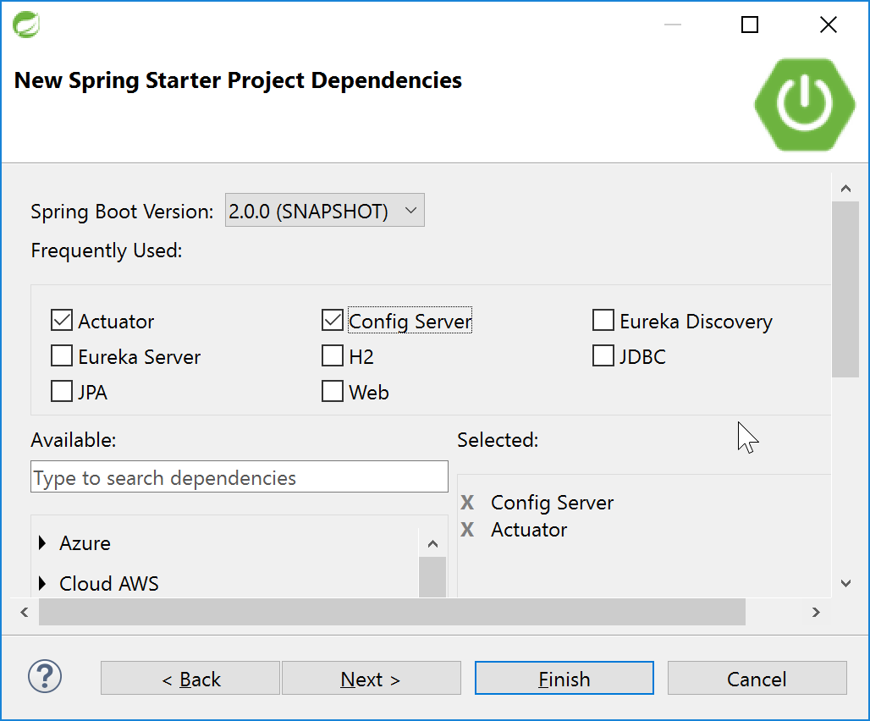

* Create application.yml

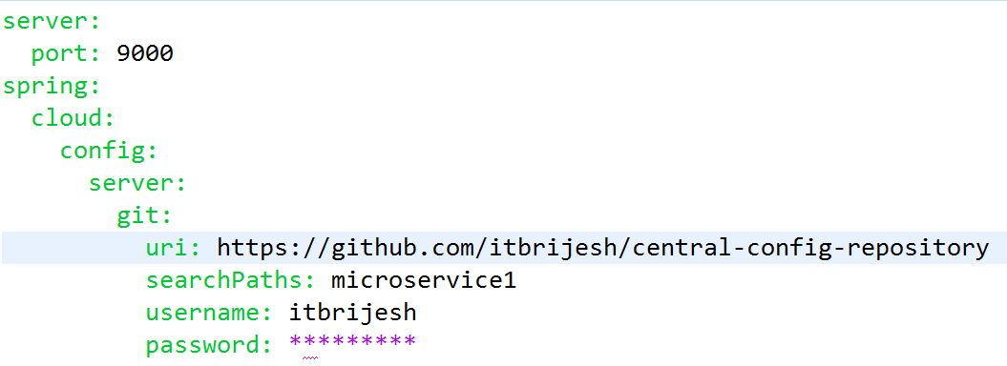

* Create bootstrap.yml

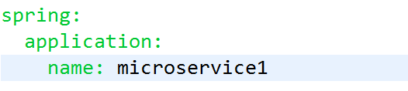

* Open bootstrap starter java class and add below annotations.

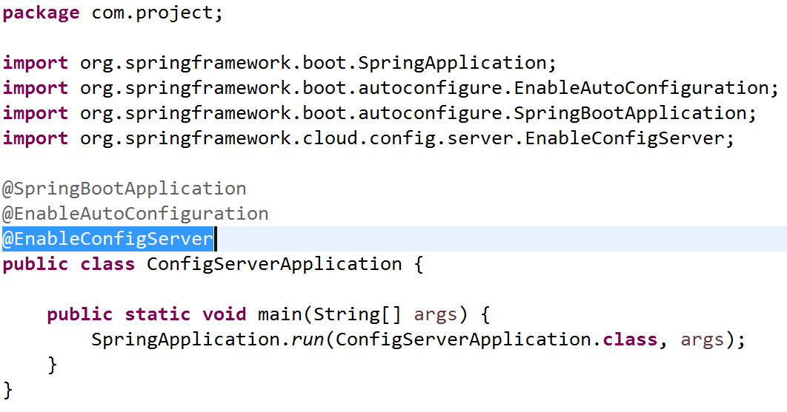

* Upload code in Github.com

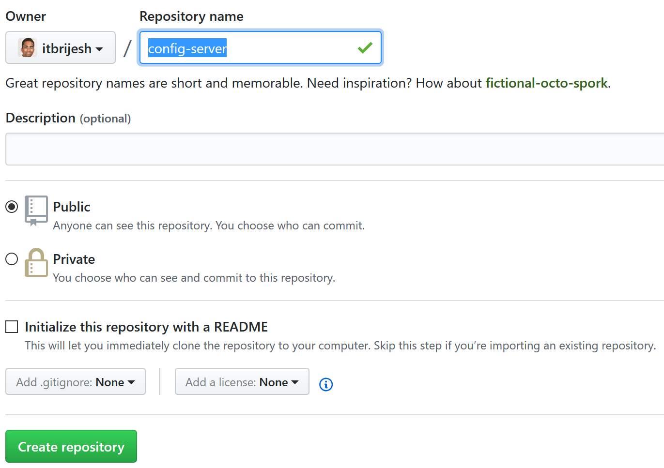

<https://github.com/itbrijesh/config-server.git>

git init

git remote add origin <https://github.com/itbrijesh/config-server.git>

git add –A

git status

git commit -m "Spring config-service server"

git push origin master